Project Report

- INTRODUCTION
1.1 Project Overview
1.2 Purpose
- LITERATURE SURVEY
2.1Abstract
- IDEATION
3.1Empathy Map Canvas
3.2 Ideation & Brainstorming
- REQUIREMENT ANALYSIS
4.1 Functional requirement
4.2 Non- Functional requirement
5. PROJECT DESIGN PHASE 1
5.1Proposed Solution
5.2 Problem Solution Fit
5.3 Solution Architecture
6. PROJECT DESIGN PHASE 2
6.1 Customer journey
6.2 Functional Requirement
6.3 Data Flow Diagram
6.4 Technology Architecture
7. PROJECT PLANNING PHASE
7.1 Prepare milestone and Activity List
7.2 Sprint Delivery Plan
8. PROJECT DEVELOPMENT PHASE
8.1 Project Development Delivery of Sprint-1
8.1 Project Development Delivery of Sprint-2
8.3 Project Development Delivery of Sprint-3
8.4 Project Development Delivery of Sprint-4
9.CODING & SOLUTION
10ADVANTAGES & DISADVANTAGES
- CONCLUSION
12.FUTURE SCOPE

GitHub & Project Demo link

INTRODUCTION

- INTRODUCTION

1.1 PROJECT OVERVIEW

Technology has brought fine changes into every portion of our life by making it smart and reliable. There are many situations in which technologies can be used to avoid accidents in roads which opens a wide window for the requirement of Smart Road System. With the dynamic changes in the models of the vehicles the roads need to have same ability to face them. Evolving towards the future, the roads needs to build with advanced sensors and antenna systems to have a pace with the new era. The design involves the road side units and vehicle side units as part of intelligent transport system involving Internet of things(IOT).This project has designed a system to alert the driver about the speed limits in specific areas by reducing the speed of the vehicles in sensitive public zones without any interference of the drivers where controls are taken automatically by the use of a wireless local area network.The main objective of the proposed system is to operate the vehicles in a safe speed at critical zones minimizing the possible risk of unwitting accidents and casualties. Besides, the system is capable of detecting the accidents and give notification to the control room. The system operates in such way that the accident information is passed to the vehicles entering the same zone to take diversion to avoid traffic congestion.

1.2 PURPOSE

The purpose of this document is to provide a debriefed view of requirements and specifications of the project called IOT Road Safety.

•The goal of this project is to operate the vehicles in a safe speed at critical zones minimizing the possible risk of unwitting accidents and casualties.I evaluate the proposed Road Safety system with the IOT connected technology.
• I propose to use node MCU s connected with IOT which controls and limits the speed in some specific areas and GPS to get the exact location where the accident may occur.

LITERATURE
SURVEY

2. LITERATURE SURVEY

TOPIC: Signs with smart connectivity for better road safety.

ABSTRACT:

Smart roads using IOT devices is a special idea which makes the drivers to drive safer than before .The first motive of smart road is to provide safety, use less amount of electricity and reduce traffic. This can be implemented by using advanced technologies like Light Sensors, Ultrasonic Sensors, Camera, Motion Sensors, IOT Devices, Interactive Lighting System, The solar roadways, Glow in the Night, The wind powered light System & The electric priority lane. Traffic is a growing problem in India causing fuel wastage, time wastage & pollution. In Indian road-traffic, the problems like crowded roads, unpredictable time to travel from one place to another are a serious problems which is also polluted and noisy. Now, researchers have started to introduce connected vehicle technology which is difficult to implement on roads. In this project, we present a low cost innovative technology for smart roads. The wastage of electricity from street lights can be minimized by using the motion sensors and light sensors due to which the loss of electricity can be prevented. Different technologies have been introduced to reduce traffic jams.

TOPIC : Problem definition for road safety.

ABSTRACT:

In India we see traffic junction, we can see traffic signals with red, yellow and green lights along with the timer display. To move the traffic has to wait for a fixed interval of time. [4] For example, people have to wait for a small interval of time which is fixed for every signal even though the traffic is more in that particular lane. [5] This leads to a huge “TRAFFIC JAM” which is a major problem now a days – the society is facing. Another problem that people face in India is “LACK OF ELECTRICITY”. Street lights are always glowing at night. For example, even if no vehicles are moving on roads at night, street lights are always glowing which is actually not necessary. Inappropriate use of street lights, electricity is used unnecessarily which is a “WASTE OF ELECTRICITY.

TOPIC: Existing System for road safety.

ABSTRACT:

The individual traffic signals are connected with traffic control system to perform network wide traffic operation. These control systems contain a central computer, a communication network, and intersection traffic signals. Coordination of control system can be implemented through different techniques like time-base, hardwired interconnection method. Coordination between traffic signals and agencies requires the development of data sharing and traffic signal control agreements. A traffic-signal system has only one purpose i.e. to deliver signal timings to the driver. The system provides features that improve the traffic engineer’s ability to achieve this goal. These are primarily access features. They provide access to the intersection signal controller for maintenance and operations.

TOPIC: Proposed System for road safety.

ABSTRACT:

Despite of the innovation made to the mobiles, vehicles etc. we see less developments to the roads. There are several work that can be done on the roads which will help in inventing new technologies and reconstructing the driving experience when it comes to road safety. The masterminds in this sector are trying hard to improve driving experience by innovating various ideas like to use roads to store solar energy from the sun directly and transfer that energy into electricity for homes. When there is a huge traffic on the one lane of the traffic signal, it should be cleared as soon as possible. But in our existing traffic system, the driver should wait until their turn comes even if there is a huge traffic in that particular lane. To avoid this we can provide sensor which are capable of analyzing the traffic intensity. These sensors can be used to clear the traffic as soon as possible before causing a traffic Jam. In this new system, sensors are used to prevent loss of electricity by the unnecessary usage of street lights at night. At nights street lights are switched 'ON' even if there are zero vehicles on road. So, in order to overcome this, sensors are used for street lights and when a vehicle passes through the sensors, the street light will be switched 'ON' and when the vehicle passes through that street light, the upcoming street light will be switched 'ON' automatically and all the foregoing lights are switched 'OFF' as the vehicle has passed through that light. This is continued throughout the street thereby saving the energy. Ultrasonic sensors are used to detect the traffic which gives a signal to RASPBERRY PI 3 about the traffic and this will be able to clear the traffic. Camera module installed on road is used to detect the vehicles that are not following the traffic rule .When there is a huge traffic on the one lane of the traffic signal, it should be cleared as soon as possible. But in our existing traffic system, the driver should wait until their turn comes even if there is a huge traffic in that particular lane. To avoid this we can provide sensor which are capable of analyzing the traffic intensity. These sensors can be used to clear the traffic as soon as possible before causing a traffic Jam. In this new system, sensors are used to prevent loss of electricity by the unnecessary usage of street lights at night. At nights street lights are switched 'ON' even if there are zero vehicles on road. So, in order to overcome this, sensors are used for street lights and when a vehicle passes through the sensors, the street light will be switched 'ON' and when the vehicle passes through that street light, the upcoming street light will be switched 'ON' automatically and all the foregoing lights are switched 'OFF' as the vehicle has passed through that light. This is continued throughout the street thereby saving the energy. Ultrasonic sensors are used to detect the traffic which gives a signal to RASPBERRY PI 3 about the traffic and this will be able to clear the traffic. Camera module installed on road is used to detect the vehicles that are not following the traffic rules.

TOPIC: The Solar Roadways for road safety.

ABSTRCT:

As mentioned in the introduction about the roads that can reserve solar energy. It is an indie go projects which wants to install the solar panels on the roads which are made of glass with microprocessors and LED's. The need for glass roads as? As glass can restore its environmental friendly and its strength can be improved. The roads are no more a midway just loco mote from one place to another Smart Roads allows us to charge vehicle and utilize the energy in an effective way. With the technological enhancement in every field, roads are not behind. There will be more future enhancement that adds good experience and make our roads smart and safe to travel.

IDEATION

3. IDEATION

3.1 Empathy Map Canvas

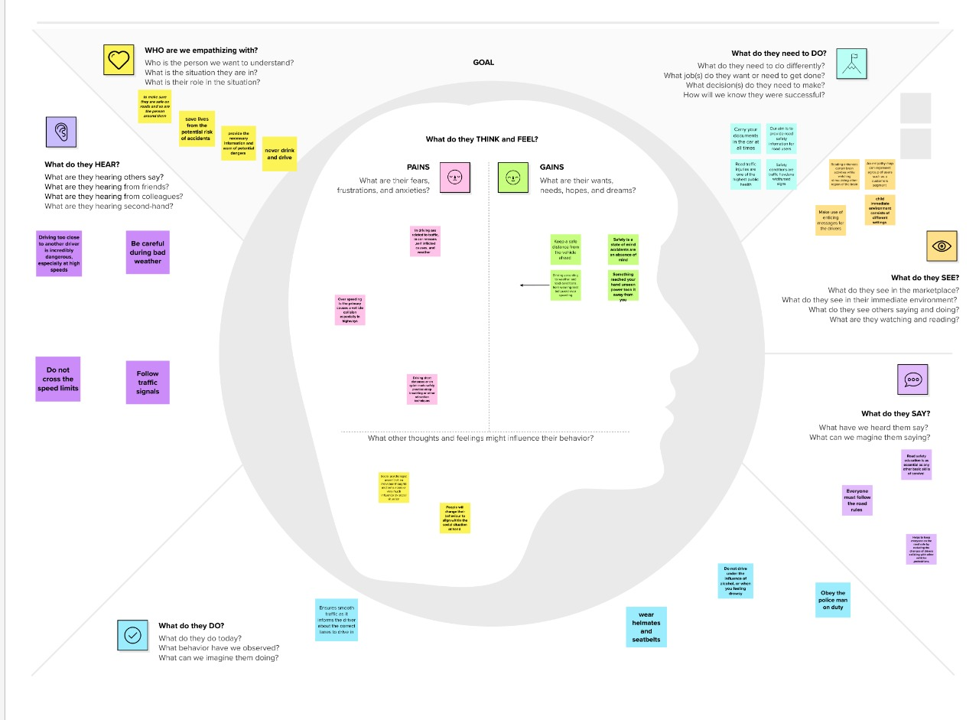

3.2 Brainstrome and idea template

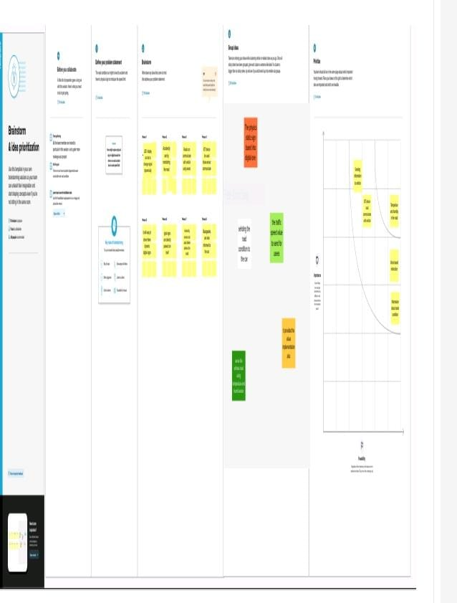

REQUIREMENT ANALYSIS

4. Requirement Analysis

4.1Functional Requirement

Business  Requirement | User  Requirement | Product Requirement
- Better Traffic Management and Safety-Through refined telematics and intelligent technology.  - It can be easier to "read" the locations and speeds of vehicles, such as those in a fleet.  - When vehicles and smart traffic control systems are connected via the cloud, the end results may be more manageable traffic, decreased gridlock, and better traffic | - Smart road systems that are deployed in Smart Cities require extensive sensor networks that create huge volumes of data on traffic flow and public transit systems.  - These systems gather data from thousands of traffic cameras, road detectors, traffic lights, parking meters, air quality and other sensors, mobility apps and connected cars. | - When vehicles approach such a sign on the roadway, vital information is imparted to their drivers via their dashboard or their head-up display.  - Along with the visual data, voice narration may also be used to indicate changing roadway conditions.  - Instead of trying to read passing road indicators, drivers are thus better able to pay attention to the road.

4.2 Non-Functional Requirement

Scalability | Portability | Compatibility
- Scalability assesses the highest workloads under which the system will still meet the performance requirements.  - There are two ways to enable your system scale as the workloads get higher horizontal and vertical scaling Horizontal scaling is provided by adding more machines to the pool of servers  - Vertical scaling is achieved by adding more CPU and RAM to the existing machines. | - Portability determines how a Compatibility,as an system or its element can be launched within one environment or another.  - It usually includes hardware, software, or other usage platform specifications.  - Put simply, it establishes how well actions performed via one platform are run on another.  - Also, it prescribes how well system elements may be accessed and may interact from two different environments.  - A program running on Windows 10 must be able to run on Windows 11 without any change in its behavior and performance. | - Additional aspect of portability, defines how a system can coexist with another system in the same environment.  - For instance, software installed on an operating system must be compatible with its firewall or antivirus protection

PROJECT DESIGN PHASE - 1

- Project Design Phase - 1

5.1 Proposed Solution Template

SL no | Parameter | Description
1. | Problem Statement (Problem to be solved) | - Driving at speed  - significantly increases both the likelihood of a crash occurring, and the severity of its consequences.
2. | Idea/Solution description | - Drive in the prescribed speed limits on the various roads.  - Always remember that "Speed thrills but kills Always put on helmets, seat belts and other safety  - equipment's before driving a bicycle/ motor cycle/vehicle.  - Light Detection and Ranging gun is a weightless and simple tool, which enables law officials to catch and  - book vehicles the speed limit.  - Traffic signs are necessary to give and warnings for drivers.  - Convey the intended  - information for routes, directions, These should be clear to message for road users to understand. Drivers tend to ignore the road signs while authorities opt not to enforce them.
3. | Novelty/Uniqueness | - Roads should be designed for the safety of all road users.  - This means ensuring adequate facilities for pedestrians, cyclists and motorcyclists.  - Measures such as footpaths, cycling lanes, safe crossing points and traffic calming measures are critical to reducing the risk of injury among these road users.
4. | Social Impact/Customer Satisfaction | - Customer satisfaction is important because it illustrates whether your customer base likes what you're doing.  - Research shows that high satisfaction leads to greater customer retention, higher lifetime value, and a stronger brand Low customer reputation.  - Satisfaction scores are  important, too.  - Responding to customer  feedback increases because it to what they have to say instead of simply seeing name on a receipt.  - You take interest with them as satisfaction shows customers that you listen about your business  them as a in their  thoughts about your  business, and you interact  well.
5. | Business Model (Revenue Model) | - Accident Detection and warming.  - Post accident  models.  - Communicate with nearby vehicles and EOCS.  - Event sensing capability.  - Future smart cities.  - Advance in smart road.  - Roads that harvest energy.  - Roads that automatically charge your vehicles.  - Improve sign age of better roads.  - Current trends in traffic signs maintenance.  - Investing in traffic signs and infrastructure.  - Smart traffic management.  - Congestion detection.  - Adaptive control  - Connected the vehicle emergency routing.
6. | Scalability of the solution | Once data are transmitted to the back end services, various workflows can be created to take necessary actions, e.g. scheduling a service with the car service provider, or if large numbers of care are in the same location, then the traffic management system can take necessary action.

5.2 Problem solution fit

1.CUSTOMER SEGMENTS | 6.CUSTOMER CONTRAINTS
*Education and training are key factors in instilling appropriate behaviour and attitudes in road users.  *Know your signals. Help your children learn about traffic lights, road signs and what each colour means.  *Stay away from distractions, such as, using your phone, chatting with passengers, eating and so on. | *More than half of all road traffic deaths and injuries involve vulnerable road users, such as pedestrians, cyclists and motorcyclists and their passengers .
2.JOB-TO-BE-DONE\PROBLEMS  *This technology allows drivers to keep control of their vehicle in hazardous conditions.  *The electronic stability control reduces engine power by automatically triggering brake pulses on the wheels | 7.BEHAVIOR  * Driver behavior is the description of intentional and unintentional characteristics and actions a driver performs while operating a motor vehicle.  *"Drug-Impaired Driving. Many types of drugs and medication, both legal and illegal, can impair your ability to drive safely....
- TRIGGERS  *Over-speeding, rash driving, violation of rules, failure to understand signs, fatigue, alcohol and medication, both legal and illegal, can impair your ability to drive safely.. | - CHANNELS OF BEHAVIOUR  *So, the most important rule of using the road is to drive to avoid accidents or harm to other road users.  *Avoid the Drowsiness While Driving.
4.EMOTIONS: BEFORE/AFTER  *Before If you're feeling particularly strained, your emotions can affect how you respond to aggressive other drivers, and lead to or risky driving behaviour.  *After in humans, including perception, attention, learning, memory, reasoning, and problem solving  5.AVILABLE SOLUTION  *Ensure the vehicle is in a roadworthy condition  *Do simple vehicle maintenance and pre-trip  inspections.  *Set all devices, mirrors and controls prior to driving. | 9.PROBLEM ROOT CAUSE  *Driving at speed significantly increases both the likelihood of a crash occurring, and the severity of its consequences.  *Non-adherence to lane driving and overtaking in a wrong manner.  10. YOUR SOLUTION  *Drive in the prescribed speed limits on the various roads.  *Keep a Safe Distance from the vehicle ahead.  *Change in the way roads are made and their maintenance is done will affect in a large way the number of accidents.

5.3.SOLUTION ARCHITECTURE

At the core of the proposed architecture is a computational core that operates in two tiers. The first is concerned with dynamically assessing the safety of each aspect in SS. The second utilizes the outcome of these three assessments to generate a single rating for the road.

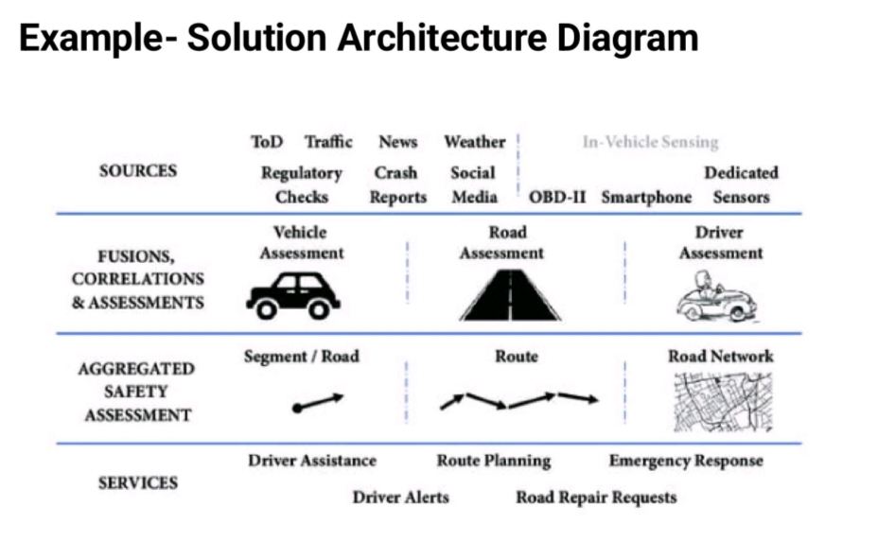

PROJECT DESIGN PHASE-2

6.1.CUSTOMER JOURNEY MAP

 | STAGE 1 | STAGE 2 | STAGE 3 | STAGE 4 | STAGE 5
OBJECTIVES | .To study the causes of accidents and suggest corrective measures at potential location. | To encourage all the travelers to follow the traffic rules and wear with helmets and seat belts while driving. | The most important objective is to measures reduce accidents considerable while using speed and the roads. pedestrian should be considered as an element not obstruction. | Road safety refers to the measures which must be adopted by everyone while using roads. | Contributing to national and global efforts to prevent death and serious injury in road crashes.
NEEDS | The people who are driving vehicles shoud have a license and proper knowledge about traffic rules and signals | Road Safety is to educate all road users in the proper and safe use of roads in order to change user attitudes and behaviour and to stimulate an awareness of the need for improvement in road safety. | Always stop, look, listen and think before crossing a road, and use pedestrian crossings wherever possible | The vehicle coming from the right has right of way over the one coming from the left at the round about. | Pedestrians should know the rules of the road so that they may see the right way of vehicles.
FEELINGS | Stress, fear, anxiety, and other emotional states of mind can and will impair your driving ability. | Shock, compassion, dismay, curiosity, sadness, fear or insecurity are strong emotional reactions that can arise in confrontations with an accident | Take Some Deep Breaths. Deep breathing isn't just for meditation and yoga class; it can also truly help calm your nerves in emotional situations. | Different networks in the brain can create the same emotion. | The most frequent emotion was joy, followed by love and anxiety.
BARRIERS | Road safety barriers are effective road restraint systems that have been effectively preventing a number of mishaps every day | The most common barrier used for driving is a speed bump. | Steel W-beam safety barriers are semi-rigid and made of steel rails mounted on posts that are designed to break when struck by a vehicle. | Physical barrier means a continuous raised barrier, raised median island or curb installed in a roadway. | The purpose of a barrier is to prevent the penetration of an area by intruders.

6.2.FUNCTIONAL REQUIREMENTS

BUSINESS REQUIREMENT | USER REQUIREMENT | PRODUCT REQUIREMENT
Better Traffic Management and Safety – Through refined telematics and intelligent technology, it can be easier to “read” the locations and speeds of vehicles, such as those in a fleet.When vehicles and smart traffic control systems are connected via the cloud, the end results may be more manageable traffic, decreased gridlock, and better traffic | Smart road systems that are deployed in Smart Cities require extensive sensor networks that create huge volumes of data on traffic flow and public transit systems. These systems gather data from thousands of traffic cameras, road detectors, traffic lights, parking meters, air quality and other sensors, mobility apps and connected cars. | When vehicles approach such a sign on the roadway, vital information is imparted to their drivers via their dashboard or their head-up display. Along with the visual data, voice narration may also be used to indicate changing roadway conditions. Instead of trying to read passing road indicators, drivers are thus better able to pay attention to the road.

6.3. DATAFLOW DIAGRAM

A Data Flow Diagram (DFD) is a traditional visual representation of the information flows within a system. A neat and clear DFD can depict the right amount of the system requirement graphically. It shows how data enters and leaves the system, what changes the information, and where data is stored.

EXAMPLE: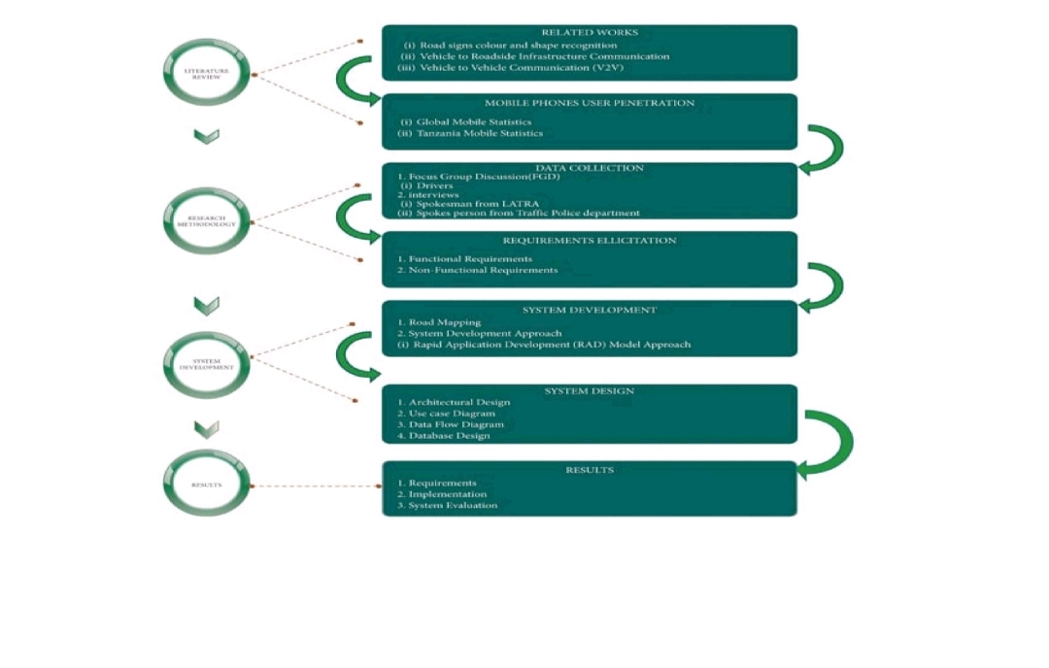

The first step was to review the literature of the relevant related studies to gain insights about road signs identification.

2. The second step was to collect data from stakeholders in Tanzania who matter as far as road safety is concerned. The purpose was to get stakeholders' inputs on the proposed work, regarding functional and non-functional requirement.

The third step was system development that began with mapping the road signs of interest to create a database of coordinates that corresponded to the alerts. This was followed by system design comprising of system architecture design, use case diagram, data flow diagram, and database design.

Furthermore, the existing related system was taken into account during the design phase. Finally, the mobile application was pretested in the study area. The results were analyzed during the final step to evaluate the system performance.

USER STORIES:

Use the below template to list all the user stories for the product.

CAPABILITY | COMPETENCE,HUMAN FACTORS
TASK DEMAND | ENVIRONMEN, VEHICLES,SPEED,OTHER ROAD USERS.
SAFETY ATTITUDES | SAFETY ETHICS,SAFETY EDUCATION.
NEGATIVE PRECONCEPTION | OCUPATIONAL RISK
PRECEIVED BENEFITS | FUNCTIONALITY.

ADVANTAGES:

Using images and symbols warns people of dangers faster and easier than words.

6.4.TECHNOLOGY STACK ARCHITECTURE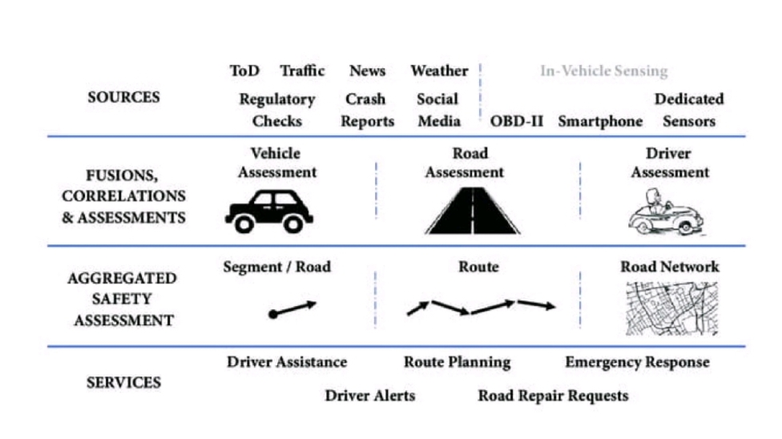

COMPONENTS AND TECHNOLOGY:

S.NO | COMPONENTS | DESCRIPTION | TECHNOLOGY
1. | EMERGENCY CARE | .The need of the hour is to ensure effective help in accidents and legal protection for Good Samaritans | smart traffic light and traffic control systems, artificial intelligence, the use of telematics and automotive technolog
2. | VEHICLE SAFETY | Many government-mandated safety features like seatbelts, airbags, and antilock brakes, are found on every car. | Automatic Emergency Braking (AEB), Crash Imminent Braking, Dynamic Brake Support, and Pedestrian Emergency Braking
3. | SPEED MANAGEMENT | .Higher driving speeds lead to higher collision speeds and thus to severer injury. | Track vehicles and adjust traffic lights based on traffic conditions, helping prevent bumper-to-bumper traffic.

PROJECT PLANNING PHASE

7.1.PREPARE MILESTONE AND ACTIVITY LIST

TITLE | DESCRIPTION | DATE
Literature survey and Information gathering | Literature survey on the selected project & gathering information by referring to the technical papers, research publications etc.. | 11 October 2022
Prepare Empathy Map | Prepare empathy map canvas to capture the user pains & gains Prepare list of problem statements. | 20 October 2022
Ideation | List the ideas by organizing the brain storming session and prioritize the top 3 ideas based on feasibility and importance. | 7 November 2022
Proposed Solution | Prepare the proposed solution document which includes the novelty, feasibility of ideas business model social impact,scalability of solution etc.. | 23 October 2022
Problem Solution Fit | Prepare problem-Solution Fit  document | 7 November 2022
Solution Architecture | Prepare a solution architecture document | 280ctober2002
Functional Requirements | Prepare the functional requirement document | 28 October 2022
Data Flow Diagrams | Draw data flow diagram for the  project and submit for review. | 28 October 2022
Technology Architecture | Prepare the technology architecture Diagram. | 7 November 2022
Customer Journey | Prepare the customer journey maps to understand the user interaction and experiences with the application (entry to exit) | 7 November 2022
Prepare Milestore and Activity List | Prepare Milestore and Activity | 7 November 2022

7.2 SPRINT DELIVERY PLAN

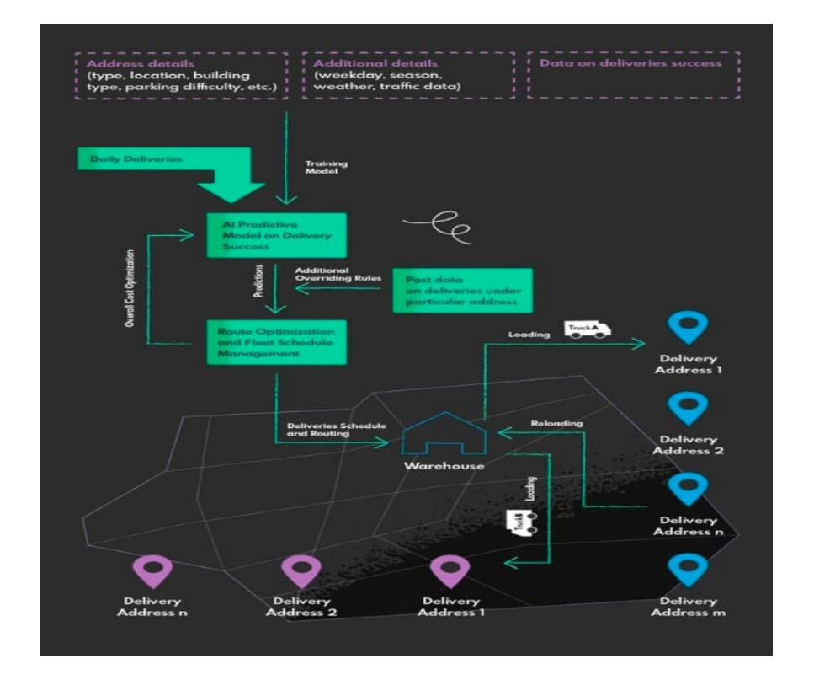

PROJECT DEVELOPMENT
PHASE

8.1 DEVELOPMENT DELIVERY OF SPRINT-1

import pygame

from pygame import gfxdraw

import numpy as np

class Window:

def _init_(self, sim, config=0)): #Simulation to draw

self.sim = sim

#Set default configurations self.set_default_config()

# Update configurations

for attr, val in config.items(): setattr(self, attr, val)

def set default config(self):

Set default configuration""

self.width = 1400

[9:32 PM, 11/19/2022] Swetha: self.height = 1000

self.bg_color= (250, 250, 250)

self.fps = 60

self.zoom=5

self offset =(0,0)

self.mouse Jast = (0, 0)

self.mouse_down = False

def loop(self, loop=None):

**Shows a window visualizing the simulation and runs the loop function.""

# Create a pygame window

self.screen=pygame.display.set_mode((self.width, self.height))

pygame.display.flip()

#Fixed fps

clock = pygame.time.Clock()

#To draw text

pygame.font.init()

self.text_font=pygame font SysFont("Lucida Console, 16)

#Draw loop

running = True

while not self.sim.stop.condition(self.sim) and running:

#Update simulation

if loop: loop(self.sim)

#Draw simulation

self.draw()

#Update window

pygame.display.update()

clock.tick(self.fps)

#Handle all events

for event in pygame.eve…
[9:33 PM, 11/19/2022] Swetha: def background(self, r. g. b):

"Fills screen with one color **

def line(self, start pos, end_pos, color). vs a line." Draws

def rect(self, pos, size, color):

** Draws a rectangle.*

def box(self, pos, size, color

*Draws a rectangle.**

def circle(self, pos, radius, color, filled=True): ***Draws a circle

def polygon(self, vertices, color, filled=True): ***Draws a polygon"

def rotated_box(self, pos, size, angle=None, cos=None, sin=None, centered=True, color=(0, 0, 255), filled=True); Draws a filled rectangle centered at *pos" with size "size" rotated anti-clockwise by "angle"

def rotated_rect(self, pos, size, angle-None, cos-None, sin-None, centered-True, color=(0, 0, 255)):

**Draws a rectangle centered at "pos" with size *size rotated anti-clockwise …
[9:34 PM, 11/19/2022] Swetha: self.background(*self.bg_color)

#Major and minor grid and axes

self.draw.grid(10, (220,220,220)) self.draw.grid(100, (200,200,200))

self.draw_axes()

#Draw roads

self.draw roads()

# Draw status info

self.draw_status()

8.2 PROJECT DEVELOPMENT DELIVERY OF SPRINT-2

Proposed system:

In present Systems the road signs and the speed limits are Static. But the road signs can be changed in some cases. We can consider some cases when there are some road diversions due to heavy traffic or due to accidents then we can change the road signs accordingly if they are digitized. This project proposes a system which has digital sign boards on which the signs can be changed dynamically. If there is rainfall then the roads will be slippery and the speed limit would be decreased. There is a web app through which you can enter the data of the road diversions, accident prone areas and the information sign boards can be entered through web app. This data is retrieved and displayed on the sign boards accordingly.

Software used

- Arduino IDE

•Embedded C

Hardware used

⚫Node MCU ESP8266
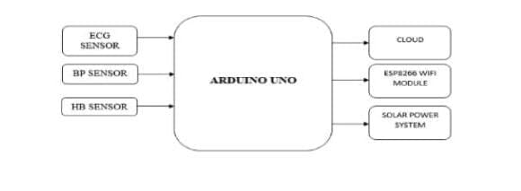
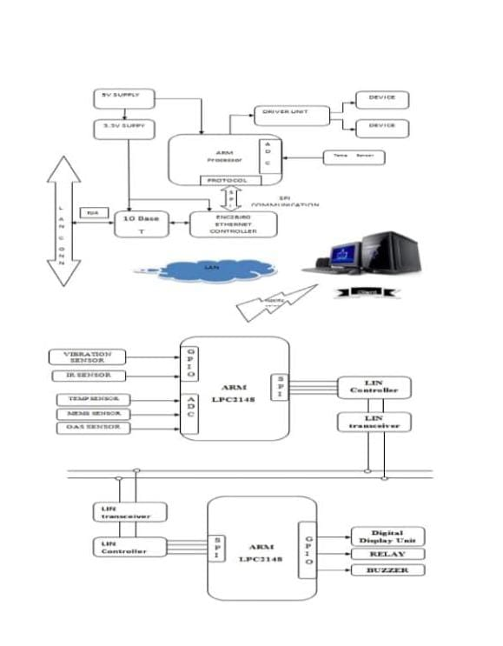
8.3PROJECT DEVELOPMENT DELIVERY OF SPRINT-3

Signs with smart connectivity for better road safety by using IOT integrated Big data analysis:

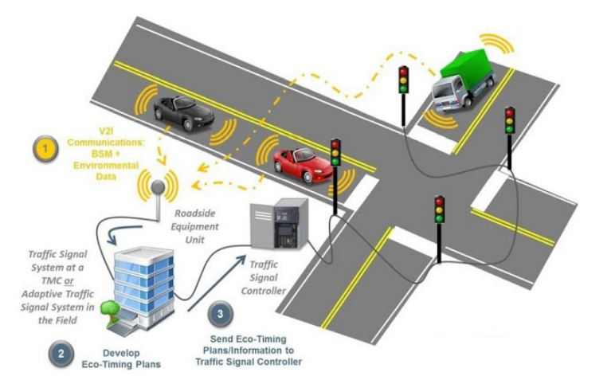

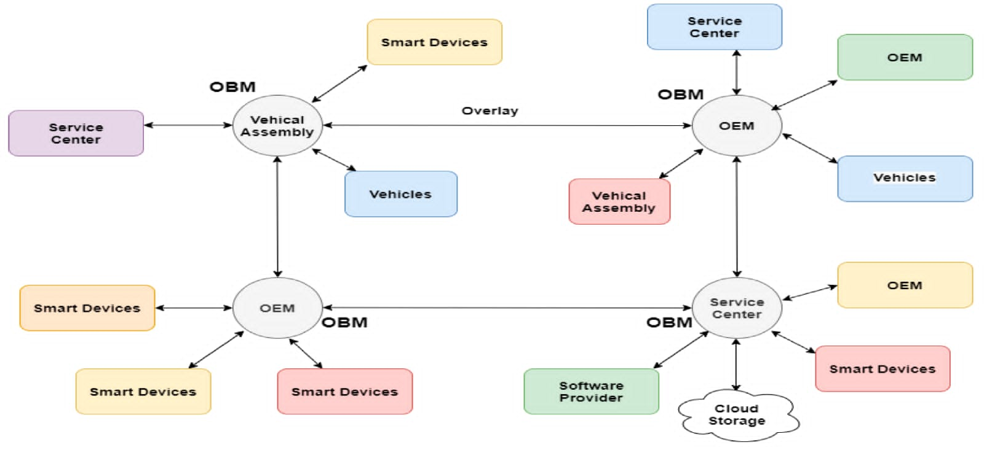

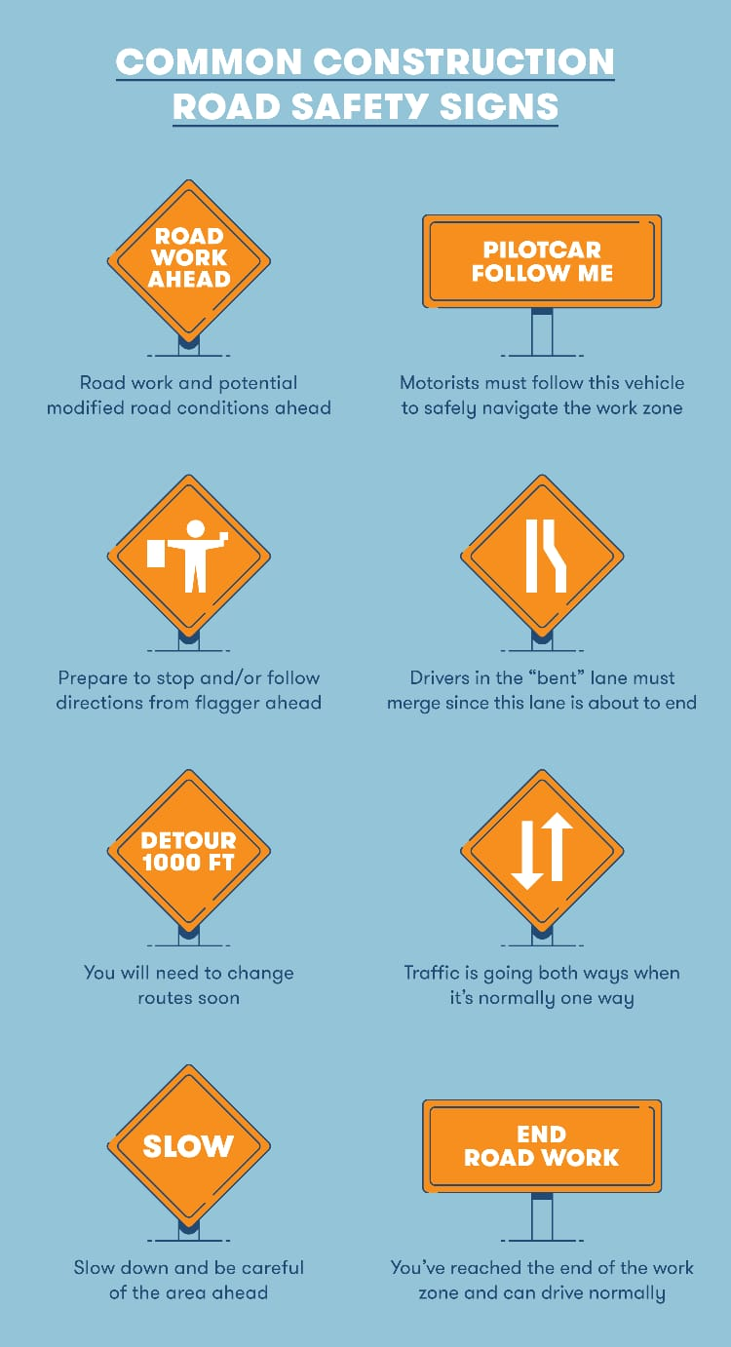
8.4 PROJECT DEVELOPMENT DELIVERY OF SPRINT-4

AN introduction to IOT based road safety deduction and monitoring system:

The Safe System Approach:

The Safe System (SS) approach to transport networks originated with the "Safe Road Transport System' model developed by the Swedish Transport Agency. In its essence, the approach migrates from the view that accidents are largely and automatically the driver's fault to a view that identifies and evaluates the true causes for accidents. Through the categorization of safety into the safety of three elements (vehicle, road, and road user), SS minimizes fatalities and injuries by controlling speeds and facilitating prompt emergency response. The model has been widely adopted since its introduction and is currently motivated by the WHO as a basis for road safety planning, policy-making, and enforcement.

An illustration of the model is provided in Figure 1. A central emphasis is given to speed in the SS approach as it is the strongest and most fundamental variable in the outcome of fatality. The fragility of the human body makes it unlikely to survive an cushioned impact at a speed of more than 30 km/h, with lower speeds resulting in either death or serious injury [3, 4]. The objective of the SS approach is that the three model elements should be designed and monitored to proactively prevent deadly speeds from happening and allow for a reduced emergency response time in the event of accident.

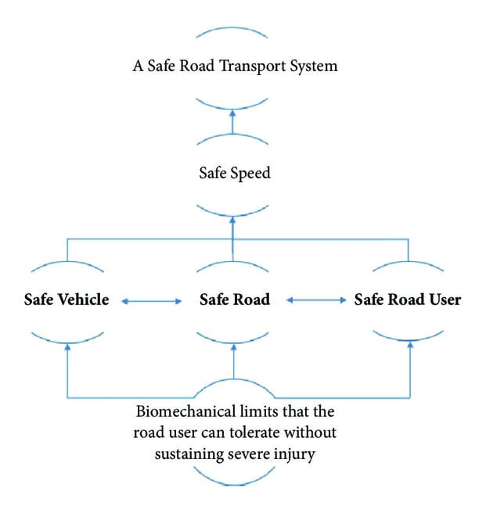

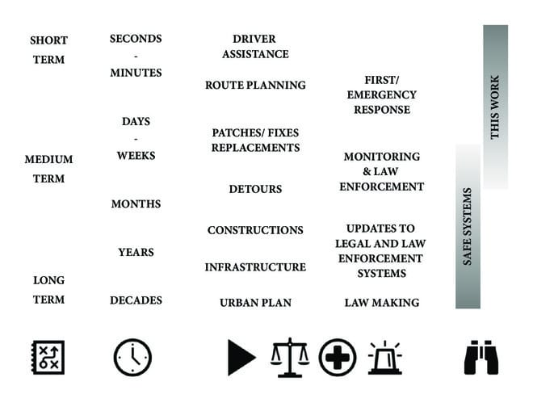

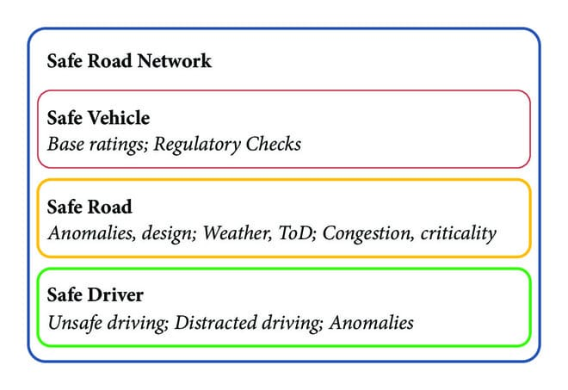

CODING & SOLUTION

- CODING & SOLUTION

#include <LiquidCrystal.h>
#define BLYNK_PRINT Serial
#include <ESP8266WiFi.h>
#include<BlynkSimpleEsp8266.h>
char auth[] = "Y4DsRJfvnDUee9LMZHCWT7pdmVLolRGU";
// Your WiFi credentials.
// Set password to "" for open networks.
char ssid[] = "hellow";
char pass[] = "12345678";
const int rs = D5, en = D6, d4 = D1, d5 = D2, d6 = D3, d7 = D4;
LiquidCrystal lcd(rs, en, d4, d5, d6, d7);
int a=0;
BLYNK_WRITE(V2)
{
a=param.asInt();
}
void setup() {
// set up the LCD’s number of columns and rows:
Serial.begin(9600);
Blynk.begin(auth, ssid, pass);
lcd.begin(16, 2);
}
void loop() {
Blynk.run();
lcd.setCursor(0, 1);
if(a==1)
{
lcd.print("accident occured");
Serial.print("hi");
}
else
{
lcd.print("welcome");
}
}
#define BLYNK_PRINT Serial
#include <ESP8266WiFi.h>
#include <BlynkSimpleEsp8266.h>
char auth[] = "q6FAQIggdIxznS2kMIbxAPn8E6nnv116";
char ssid[] = "hellow";
char pass[] = "12345678";
String str;
void setup() {
Serial.begin(9600);
Blynk.begin(auth, ssid, pass);
}
void loop() {
Blynk.run();
if(Serial.available()>0)
{
str=Serial.readStringUntil(’/n’);
// Serial.print(str);
// Blynk.notify("location:");
Blynk.notify(str);
}
}
#include <TinyGPS++.h>
#include <SoftwareSerial.h>
TinyGPSPlus gps;
SoftwareSerial ss(3,4);
char n;
int a;
void setup() {
Serial.begin(9600);
ss.begin(9600);
pinMode(2, INPUT);
pinMode(6,OUTPUT);
pinMode(11,OUTPUT);
pinMode(10,OUTPUT);
pinMode(9,OUTPUT);
pinMode(12,OUTPUT);//apr
digitalWrite(11,HIGH);
digitalWrite(6,HIGH);
attachInterrupt(digitalPinToInterrupt(2),piezo, CHANGE);
}
void loop() {
n=Serial.read();
// Serial.println(" ");
delay(200);
if(n==’3’)
{
digitalWrite(6,HIGH);
digitalWrite(11,HIGH);
digitalWrite(12,HIGH);
delay(200);
digitalWrite(12,LOW);
}
else if(n==’2’)
{
digitalWrite(6,LOW);
digitalWrite(11,LOW);
digitalWrite(10,LOW);
digitalWrite(9,LOW);
digitalWrite(12,HIGH);
delay(200);
digitalWrite(12,LOW);
}
else if(n==’1’)
{
analogWrite(11,100);
analogWrite(6,100);
digitalWrite(12,HIGH);
delay(200);z
digitalWrite(12,LOW);
}
}
// while (ss.available() > 0)
// if (gps.encode(ss.read()))
// displayInfo();
void displayInfo()
{
// Serial.print(F("Location: "));
if (gps.location.isValid())
{
Serial.print(gps.location.lat(), 6);
Serial.print(F(","));
Serial.print(gps.location.lng(), 6);
}
else
{
// Serial.print(F("INVALID"));
Serial.print("10.305125");
Serial.print(’,’);
Serial.print("76.389582");
}
/* Serial.print(F(" Date/Time: "));
if (gps.date.isValid())
{
Serial.print(gps.date.month());
Serial.print(F("/"));
Serial.print(gps.date.day());
Serial.print(F("/"));
Serial.print(gps.date.year());
}
else
{
Serial.print(F("INVALID"));
}
Serial.print(F(" "));
if (gps.time.isValid())
{
if (gps.time.hour() < 10) Serial.print(F("0"));
Serial.print(gps.time.hour());
Serial.print(F(":"));
if (gps.time.minute() < 10) Serial.print(F("0"));
Serial.print(gps.time.minute());
Serial.print(F(":"));
if (gps.time.second() < 10) Serial.print(F("0"));
Serial.print(gps.time.second());
Serial.print(F("."));
if (gps.time.centisecond() < 10) Serial.print(F("0"));
Serial.print(gps.time.centisecond());
}
else
{
// Serial.print(F("INVALID"));
}*/
Serial.println();
}
void piezo()
{
while (ss.available() > 0)
if (gps.encode(ss.read()))
displayInfo();
}
int a=0,b=0,c=0,d=0;
void setup() {
pinMode(D1,INPUT);
pinMode(D2,INPUT);
pinMode(D3,INPUT);
pinMode(D4,INPUT);
digitalWrite(D1,LOW);
digitalWrite(D2,LOW);
digitalWrite(D3,LOW);
digitalWrite(D4,LOW);
Serial.begin(9600);
}
void loop()
{
a=digitalRead(D1);
if(a==1)
{
Serial.print("1");
}
b=digitalRead(D2);
if(b==1)
{
Serial.print("2");
}
d=digitalRead(D4);
if(d==1)
{
Serial.print("3");
}
}

ADVANTAGES
&
DISADVANTAGES

Advantages of traffic signals are as follows:

- Traffic signals help for movement of traffic securely without any collision.

- They can reduce the number of accidents on roads like pedestrian accident and right-angle collision of two cars.

- Signals can increase the capacity of traffic handling at the intersection.

- The traffic signals help for the safe movement of slow-moving traffic by interrupting heavy traffic at regular intervals.

- The indications of the signals can be seen easily in foggy weather or at night time. Without signaling system, it is very difficult to control traffic by the traffic policeman at night or in foggy weather or on a rainy day.

- Traffic control by signals is accurate and economical as compared to traffic police control.

- Under favourable conditions, they provide for continuous motion of traffic along a specified path.

Disadvantages of traffic signals are as follows:

1. They delay the traffic by stopping the vehicles at the intersection during peak hours.

2. During signals breakdown, there are serious and wide-spread traffic difficulties during peak hours.

CONCLUSION

We have presented a system, to alert the driver about the speed limits in specific areas and reduce the speed of the vehicles in sensitive public zones without any interference of the drivers where controls are taken automatically by the use of a wireless local area network. In the initial phase, we designed the basic block and circuit diagram for the system. In the implementation phase, we executed the hardware with the help of IOT connecting technologies such as Blynk app.Extensive experiments conducted on IOT and other connecting technologies.

FUTURE ENHANCEMENT

We can be enhanced this system by implementing camera using Raspberri pi, GSM module in case of network unavailability and low RAM module/zigbee
module for long range communication.

GitHub & Project Demo link -
https://youtu.be/YKmAieWhjPw

